POWERMATIC 3520B
With tool/ballast box upgrade

After several years of making lots of shavings and dust with a small but highly modified lathe, I opted for an upgrade and purchased a POWERMATIC 3520B. What a difference a “professional” grade tool makes!

The following narrative chronicles my experience from the delivery of my new “baby” and setup, to the addition of a ballast/tool box for my “Mustard Mistress” (my wife’s words, not mine). I sincerely hope you enjoy my journey.

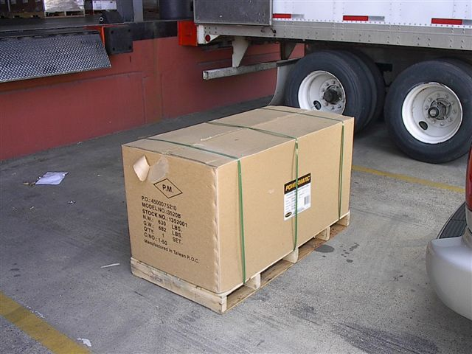
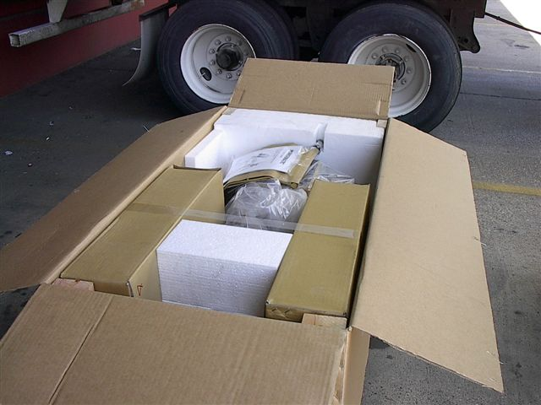
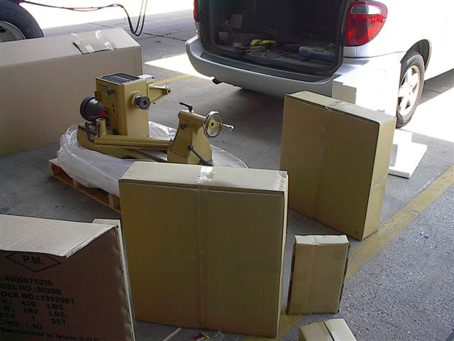

The new “baby” arrived quicker than expected (don’t they always) and I greeted it with tools and a willing heart. It was well packaged with no damage and easy to disassemble. So with a little help from a friend, I was able to load it into my van and start the journey back to its new home.

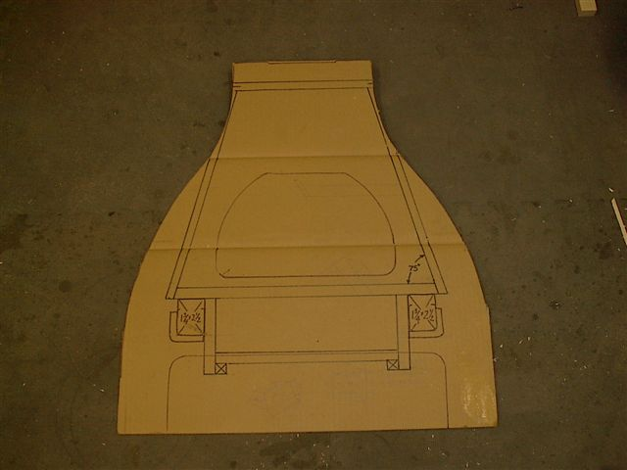
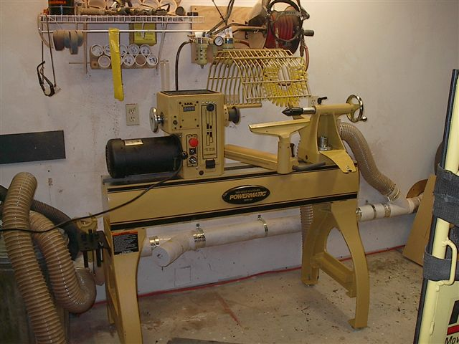
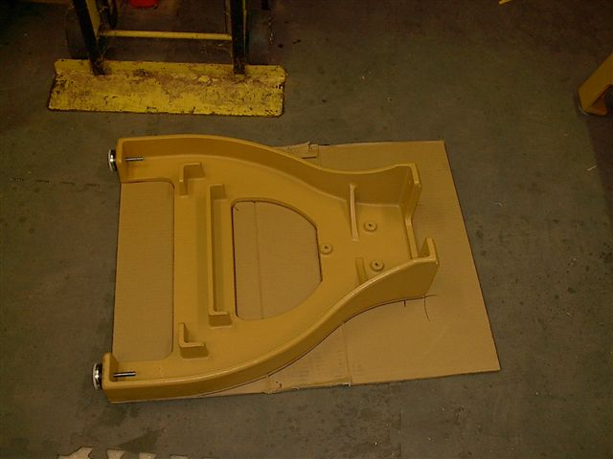

Using one of the legs as a template, I drew the outline on a piece of the shipping cardboard and began the layout design of the ballast/tool box that I had envisioned while awaiting the arrival. Setup was very easy. In two hours it was positioned and ready for the addition of my upgrade.

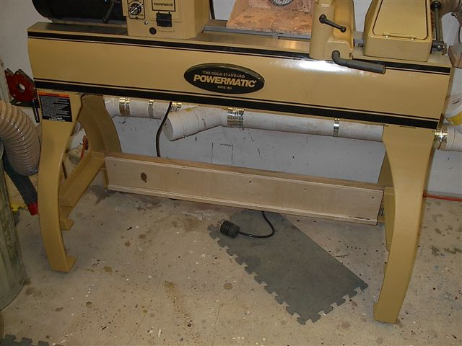
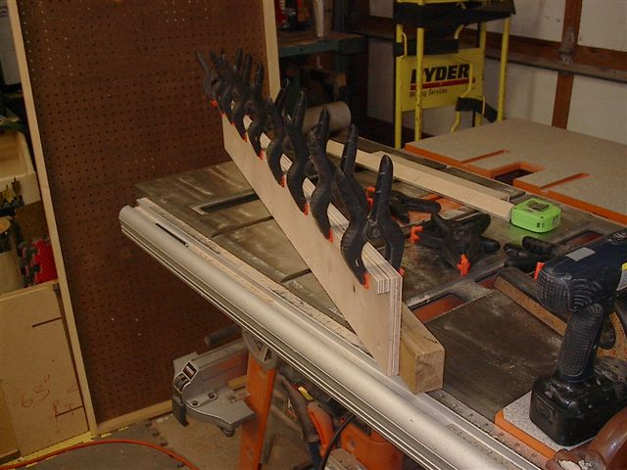
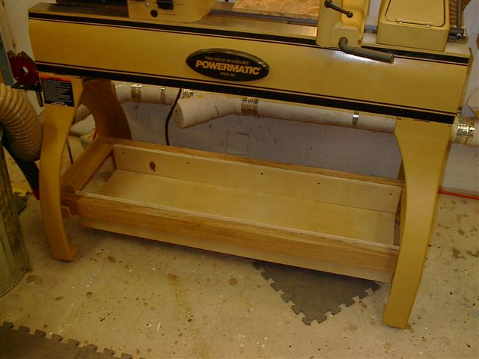

Support for the ballast box consisted of (2) 1¾” x 2½”x 49” Oak members, cut to fit the support mounts in the PM legs. ¾” x 6” x 45” Baltic Birch ply was glued and screwed to the oak and a ¾” x ¾” lip was glued to the plywood to support the ¾” x 12”x 45” bottom of the ballast box.

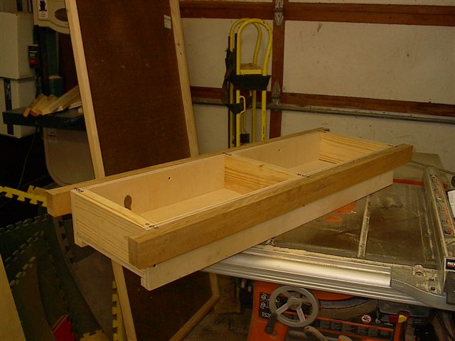
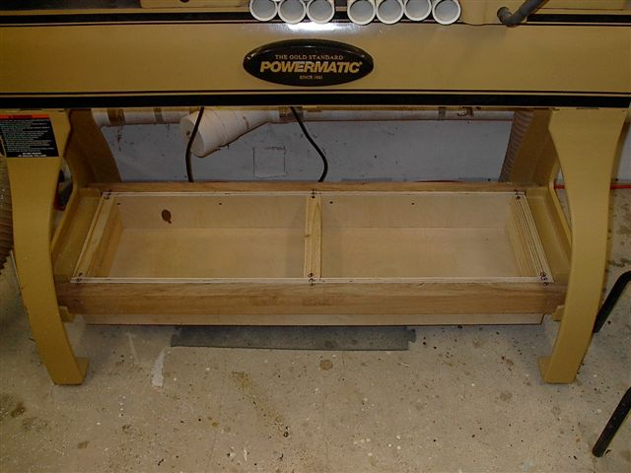
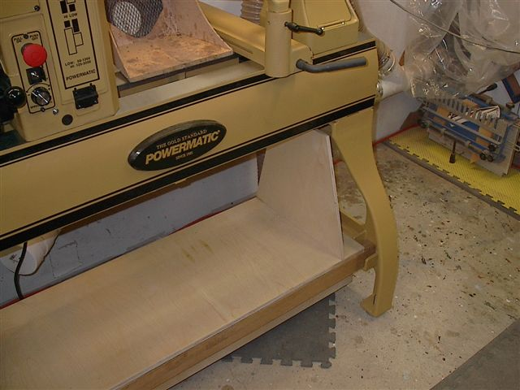

Dimensional 2 x 6’s were cut to fit the box and then screwed into the oak and the plywood, thus creating the two compartments for the ballast sand. Everything needed to be disassembled for painting so the 2 x 6’s were not glued. The ¾ x 16 ¾ ” x 45” plywood top was screwed in place.

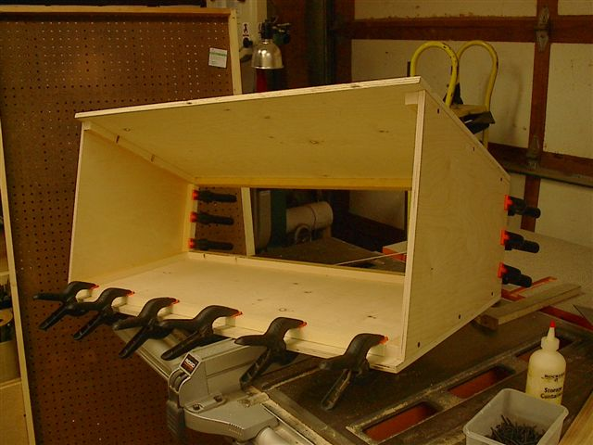
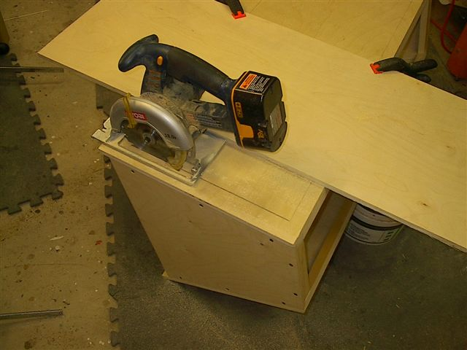
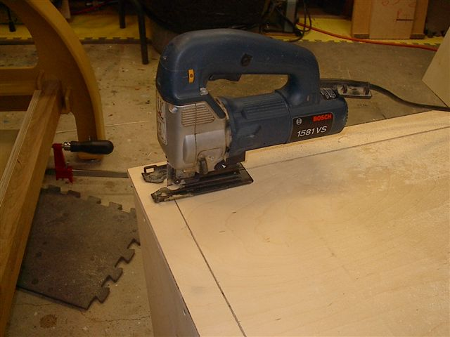

Calculating the box piece sizes was easy, using the cardboard template I’d created and it was assembled by gluing ¾” x 1” pine strips to the edges and then screwing all the pieces together. The door was laid out and then cut using a straight edge, with a jigsaw to finish cut the corners.

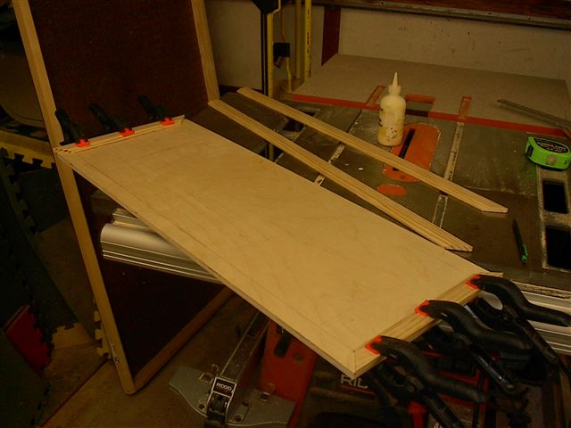
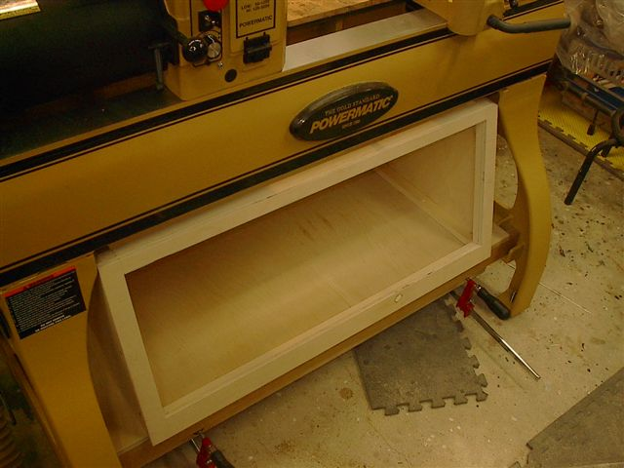
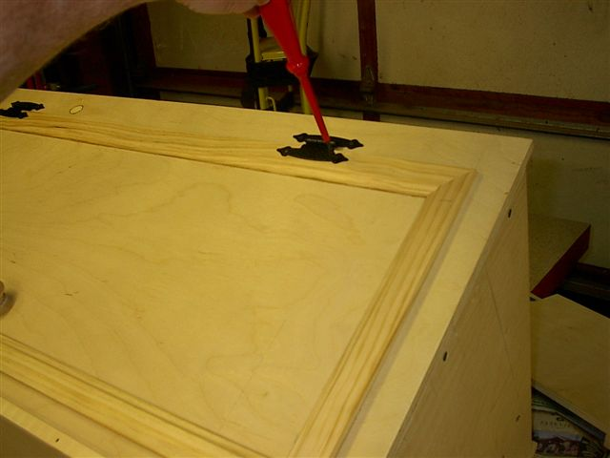

Door stop molding was used as the trim for the door and glued in place. The trim was allowed to overhang the door on the top and both sides by ¼” but the bottom of the trim was held flush with the plywood. “Hammer finish” hinges were used but a piano hinge could be substituted instead.

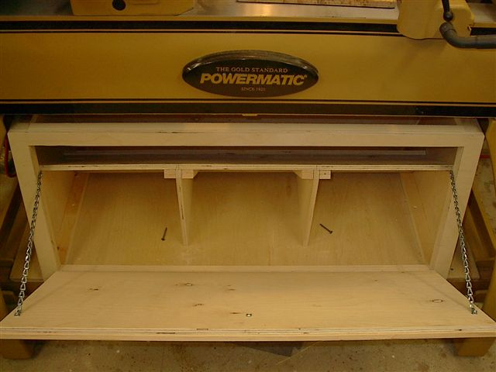
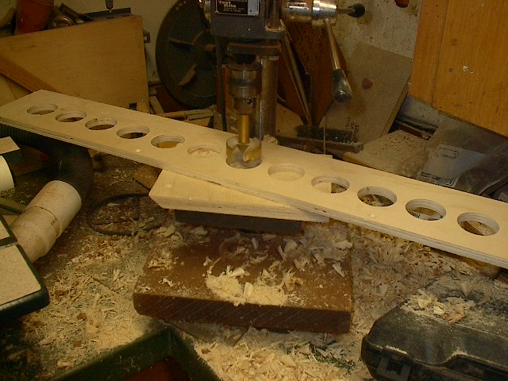
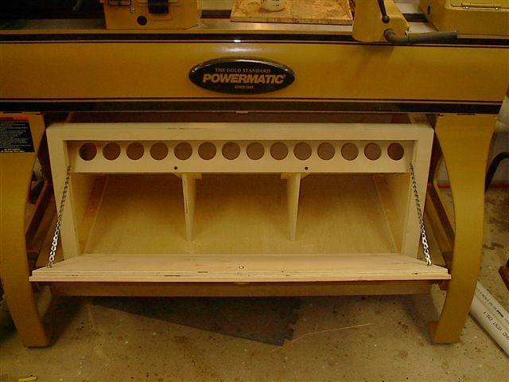

Chain holds the door open. The ½” x 10” x 37” tool sleeve shelf w/ “fitted” angled supports was added. The shelf and supports are not glued. The sleeve holes were drilled in the ½” x 5” x 37” ply with a 1.875” bit to fit 1½”x 10” PVC-DWV tool sleeves and then screwed into position.
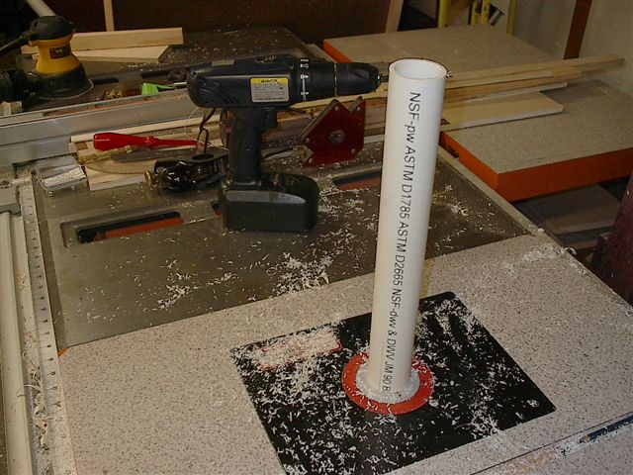
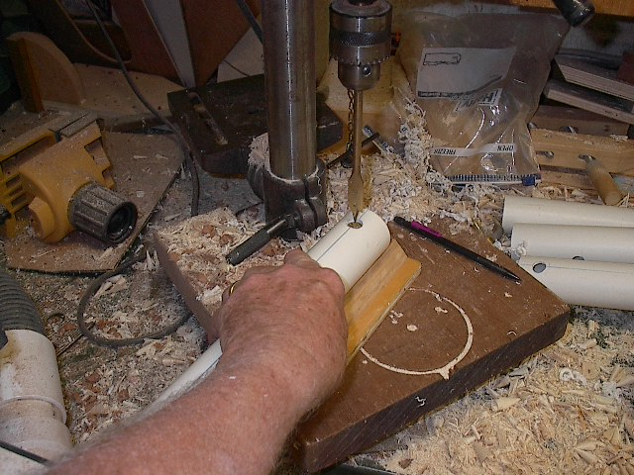
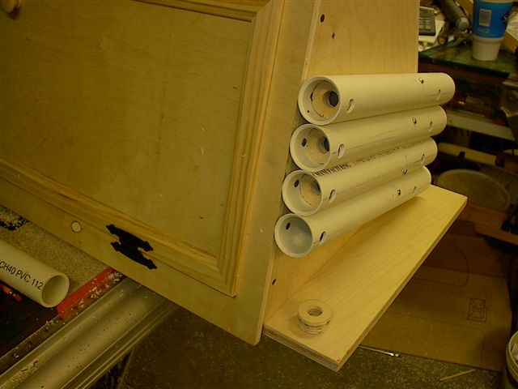

A chamfer was routed on the inside of each tool sleeve and the exterior tool sleeves were drilled for screw access during installation to the outside of the tool box. ¾” ply was drilled with a ¾” spade bit and then cut and sanded to fit the interior of each sleeve forming a stop for each tool.

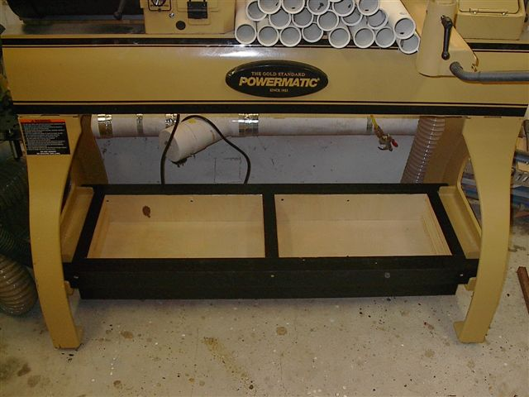
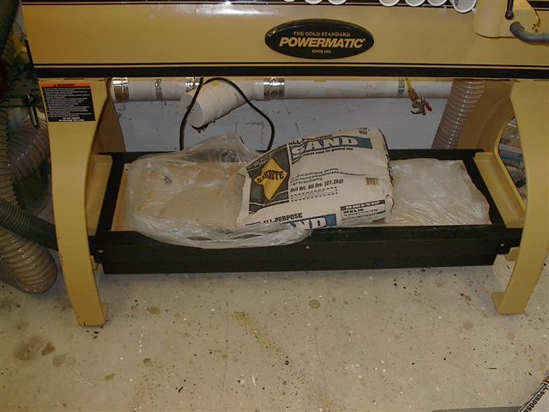
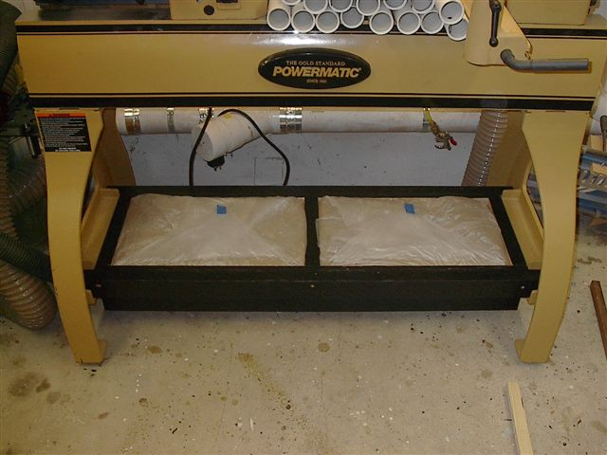

The Ballast box was disassembled, painted and then reassembled between the legs. 60# bags of sand were emptied into plastic garbage bags positioned in each compartment. The sand filled the cavities completely, it was leveled and the bags folded and taped. Voila! 120# of great ballast!

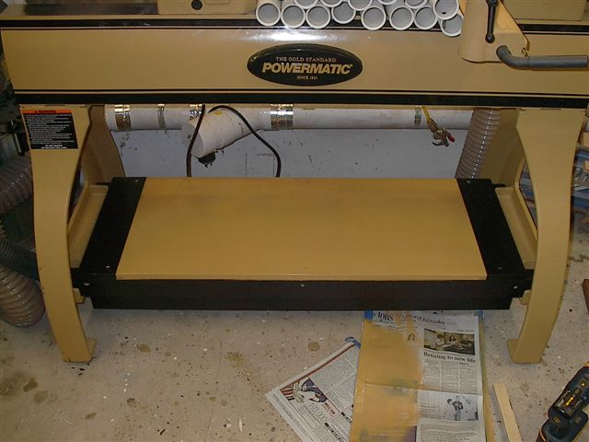
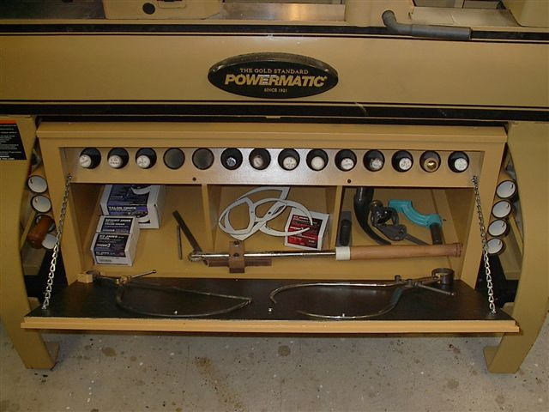
The top of the ballast box (bottom of the tool box) was painted and screwed into position. The box was painted and screwed into position. The shelf was fitted and tool sleeves installed inside and out. Tools, calipers and other turning accessories were stored awaiting the first test drive. If you have any questions, you may email me at ray.lanham@coeur-de-larbre.com I want to extend my appreciation to Marco Berra. I don’t know how many times I’ve read his article on building one for his Jet 1642 and wished for a bigger lathe so I could build one too! Thanks Marco!


