A “Performax-esk” Shop Built Drum Sander
with a little help from www.stockroomsupply.com

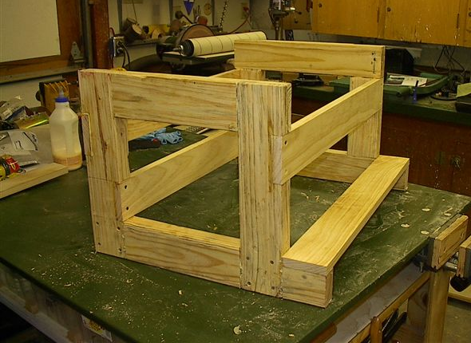
Only a “true blue/fair dinkum” woodworker with saw dust in his/her veins will understand that I “lusted” for a Performax Pro 24” drum sander . Having no inclination or hubris for marital squabbling, nor the finances to procure such a $2,000 beauty, I was unwillingly content to live my shop life pining for the machine that would make all my sanding dreams come true. Searching the net in pursuit of a more humble means of satisfying my longing for wood dust and smooth surfaces, I discovered Dominic Pieranunzio, http://www.rockslide.org/drum%20sander.html a woodworker extraordinaire. Using Dominic’s examples, photos and the link for a luthier’s pdf PLAN, for a shop built drum sander, I was able build my own version shown here.
The plan, as you will see, is for a floor model drum sander. Since floor space is at a premium in my shop. I opted for a table top model that will fit an existing mobile base that performs double duty for my new drum sander and router table. This photo shows the 2x4 frame, with lap joints, in initial stages. The 1x4’s were later doubled for added strength but I basically followed the PDF plan with a few alterations. First, I wanted a larger bed so the size was increased from 12” to 20”. Next, I really didn’t relish the thought of cutting 27 circles in ¾” plywood, gluing them to a 5/8” rod and sanding them smooth as is called for in the plan in order to produce the drum itself.
Having found the plan I wanted to use, I was breezeless on the ocean of progress when I attended the “Wood Show” that travels the country and discovered STOCKROOM Supply www.stockroomsupply.com and their V-Drum Sander kits. I purchased the “Works” 24” extended model and I was on my way home, delighted that I could once again hibernate in my shop as I tinkered to build my “Performax-esk “clone.

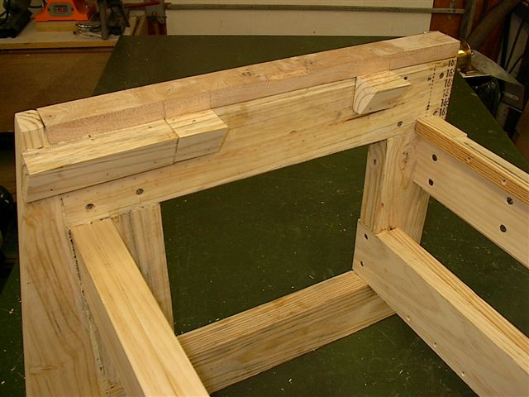
After doubling the 1x4’s and adding hardwood to strengthen the bearing surfaces on the top of each end, I nailed and glued the angled pieces shown here for support of the dust hood which you will see later. Polyurethane glue was used on all the joints and Titebond II was used on all other glued surfaces. The framing material I used was pine but the plan called for hardwood. I thought that this might pose a problem but my fear was unfounded and upon completion the unit is as steady as a rock.

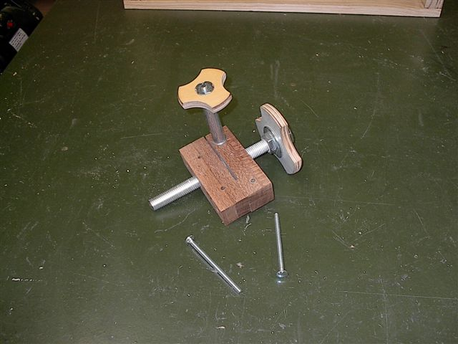
The table elevating/lowering mechanism in the plan is remarkably well thought out. I made no alterations to its design with the exception of the adjustment knobs. My knobs were made from ½”MDO plywood. Drawing a 2” and 4” dia. circle with a compass, I divided the circumference of each circle by its radius giving me 6 divisions. I cut out the circles on a band saw, and rounded the edges with a round-over bit in my router. A T-nut is used to fasten the smaller knob to its bolt and two jam nuts with large washers were used to attach the larger knob to the ¾” threaded rod. (2) ¼” carriage bolts attach the mechanism to the frame.

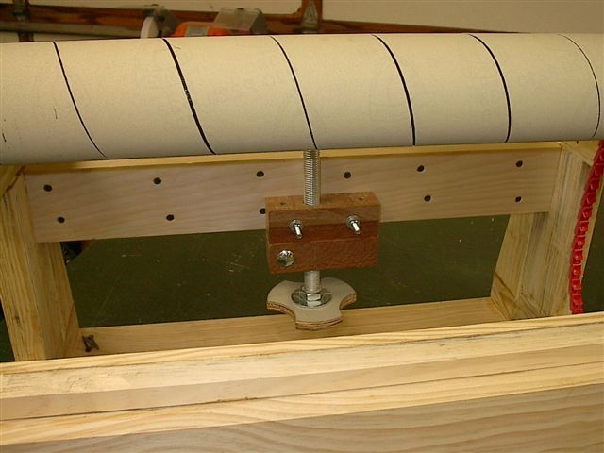
This photo shows the mechanism mounted to the frame with the V-Drum in place. I spent a lot of time dry fitting all the components to make certain that I would have no surprises during final assembly. The end of the ¾” threaded rod is rounded over on my grinder. I used a nylon washer as a bearing surface where the bottom of the table top meets the top of the threaded rod. Dominic used a custom machined brass washer on his table top. You’ll have to decide which you will use but nylon washers are inexpensive and if one wears out (which I doubt) replacing it will be simple.
The V-Drum is polycarbonate and comes with the Velcro already applied making installation of the paper a snap.

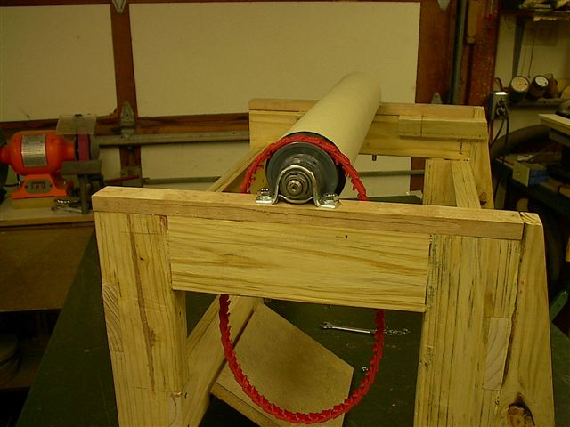
The link belt and bearings that came with the kit are shown here. I used sink cut-outs from a kitchen counter supplier for the table top and the motor mount, which you see in this photo. A piano hinge was used to anchor both the table top bed and the motor mount to the frame. I wanted my motor to be on the left side of the frame and it needed to turn counter-clock wise to make the drum rotate in the correct direction. I plan to add a 16” disk sander to the opposite end of the shaft which conveniently extends several inches past the end of the polycarbonate drum. I wanted the disk sander to turn clockwise when facing it, so I needed the motor to be mounted as shown in the photo. I was unable to use the pulleys that came with the kit because the motor I found , (a 2HP Dayton, another real bargain, thanks to Tom in Whitewright, TX) was 3450 rpm and I needed to slow it down. I replaced the supplied 3” pulleys with a 1.75” on the motor and a 4.5” on the drum. This reduced the relatively fast 3450 rpm to a manageable 1341 rpm.

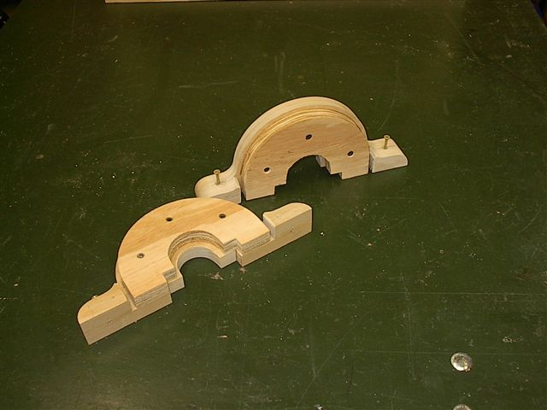
In order to cover the bearings on each end of the unit, the pdf plan calls for covers to be made from ¾” wood with a routed rabbet to accommodate the metal dust cover. I opted for making them from two pieces to eliminate the routing and give added “Beef” to the ends. Using ¾” poplar I cut the ends to shape as per the plan. Then I cut ¾ plywood to match the shape but allow for the sheetmetal ends to be covered. I added “small feet” to each end of the poplar so that the total thickness would be 1½”. Since the resulting rabbet was 3/16”, I cut spacers from 4” SWD plastic pipe to fill out the rabbet and meet the top of the poplar.

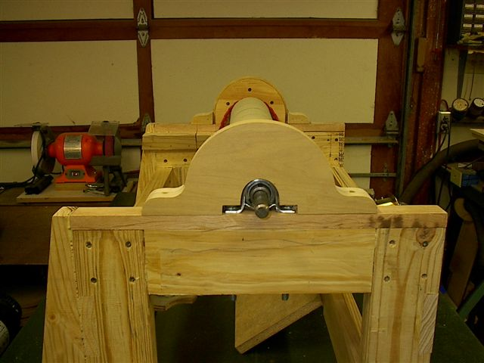
Here the bearing covers are show in a “dry-fit”. The 3/8” bolts that hold the bearings to the hardwood surface go all the way through the 2x4 and screw into 3/8-16 T-nuts mounted in the bottom surface of the 2x4. This provides a very positive fastening method and should eliminate any worry about them loosening in the future. There is enough of the bolt protruding from the T-nut that I can add a Nylok nut on the bottom to really secure them and prevent any loosening. I have a lock washer as well on the top of the bolt. My design calls for an angled front edge on the frame and the on/off switch (purchased from Rockler) will be mounted at that angle to facilitate ease of operation.

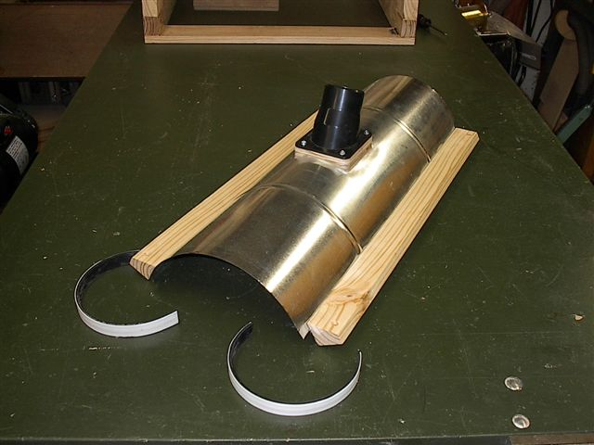
Here a piece of 6” dia. ducting has been cut to fit the end covers. A 2”x3” piece of ¾” plywood was been cut on the band saw to fit the curve of the sheet metal shroud and the plastic dust collection connection has been screwed and glued to the plywood. Once the curve was correct on the plywood. I cut the hole in the sheet metal, and using polyurethane glue, attached the plywood using sheet metal screws from the inside of the dust shroud. The angled wood pieces on the sides are for added strength and to provide a fastening surface to attach the shroud to the frame. They were attached with polyurethane glue and ¼” crown staples, using a pneumatic staple gun. The white half circle pieces shown are the 4” SWD spacers I referred to in the top photograph. Since my unit was going to be more than 24” wide over all, I had to purchase a 5’ section of sheet metal duct. Should you choose to build this unit and make it less than 24” wide, the ducting can be purchased in 24” lengths from Home Depot. This section was masked, then paint and polyurethane varnish was applied to the wooden surfaces. With the sheet metal wrapping the wooden bearing covers above and the plywood dust collection base glued to the curve, the surface was quite strong. The shroud is held to the frame with a screw through each end of the side pieces and fastened to the angled pieces shown in photograph #2.

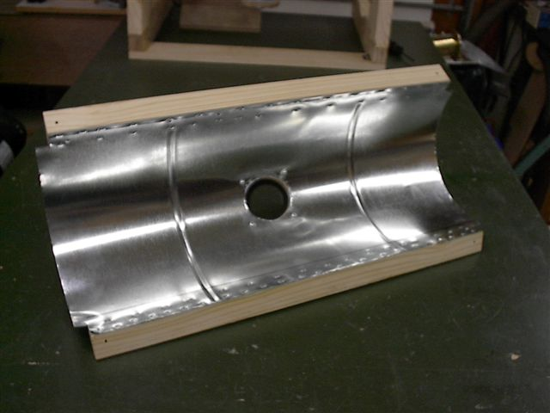
Here you can see the dust collection hole cut in the shroud, the 4 screws holding the plywood base to the outside surface and the fastening method for the side pieces. I had to reduce the pressure on the pneumatic staple gun to keep from shooting the staples through the thin sheet metal. This fastening method worked quite well and is another departure from the pdf plan. The screw holes at each end of the wooden side pieces can also be see in this photograph. This would have been a very difficult procedure if it had not been for the polyurethane glue and the staples. They made this step very easy.

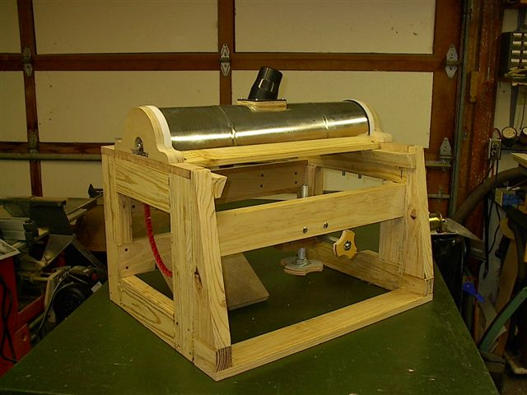
In this photo, you can see the unit in final dry assembly prior to attaching the plywood sides, on/off switch and the motor. Everything fits so now it’s time to complete this baby and see if all my hard work was worth the effort. The motor mount board was removed from the frame so that mounting holes could be drilled. 5/16” carriage bolts hold the motor to the mount and Nylok nuts with washers were used to keep the unit stable and the nuts from loosening. The link belt provides smooth running power to the V-Drum but with any motor, there will always be vibration so I wanted to make certain that this would never be problem.

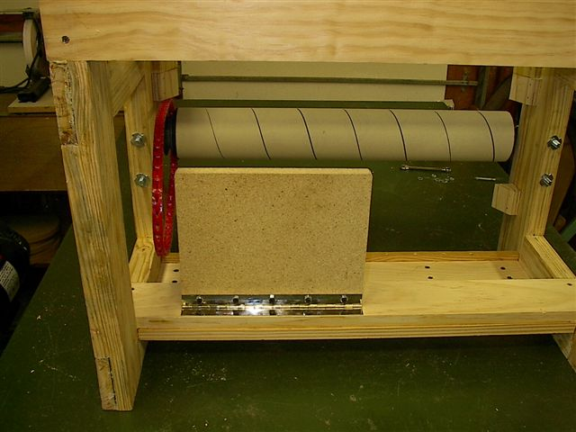
One final look at the undercarriage and you can see the T-nuts that hold the bearing bolts. The piano hinge attached to the motor mount is under the unit rather than above the mount. The pdf plan shows the hinge above the motor mount and using that configuration would allow the screws to pull out of their holes over time because of the motor weight. Placing the hinge under the motor mount eliminates that problem and provides a good secure method for mounting the motor. All parts were removed from the assembly to facilitate the painting and finishing process. Individual components were then reassembled after the finishing was complete. Prior to painting the frame, ½” birch plywood panels were glued and screwed to the outside sides of the sander. Course thread drywall screws were used throughout the construction process. A pneumatic nailer and staple gun were used for assembling various parts but the main strength of the unit is a result of the various glues used to create the final bond.

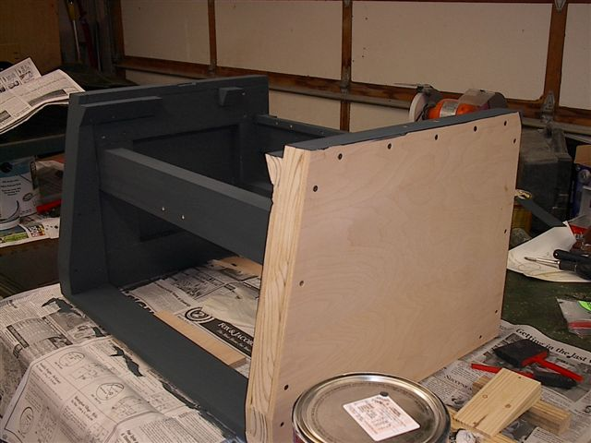
A good quality latex paint was brushed on all the interior parts of the unit and a foam roller was used on the flat plywood sides. Once the paint was dry, I lightly sanded the outside surfaces and applied one coat of polyurethane varnish to all interior and exterior surfaces. The urethane provides a very scuff resistant surface finish and gives the sander a near professional appearance.

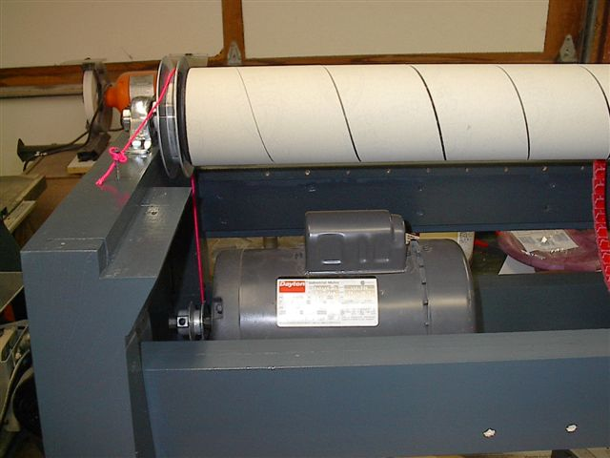

After completing the finish on the sander it was time to align the pulleys on the motor and the V-Drum. I “propped” up the hinged motor mounting platform to near level and using a plumb bob on a piece of neon pink string, I was able to position the motor correctly. Making a few alignment marks, I removed the mounting platform, drilled the holes for the 5/16” carriage bolts, installed the Nylok nuts & washers and bolted the motor down.

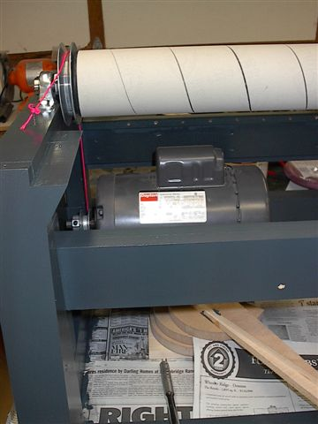
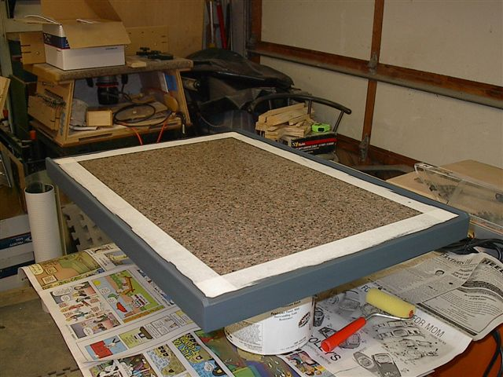
The motor is larger than I had planned at 2 hp but it runs very well and there should never be a fear of “bogging down” the motor during the sanding process. However, a 1½ hp motor should be more than enough to operate this sander. After several “test runs”, I was able to measure that the elevation control allows the removal of about 1/128th or .007 thousands of an inch of hardwood with a 1/6th turn. of the knob. That’s more than enough to achieve a very smooth surface with 120 grit sand paper. A courser paper, say 80 or 100 grit, will allow the removal of more wood but the resulting surface will be less smooth. Since I plan on using the sander to surface segmented rings for bowl turning, I’m more concerned with flatness than smoothness and thus far, my “Performax-esk” (just try saying that fast) drum sander works very well indeed.

Although all the work must be hand fed into the V-Drum, the Formica surface on the table bed of the sander allows easy access to the whirling V-Drum and the push guide (seen in the final photo) makes insertion easy and smooth. Here you can see the two sink cutouts that were glued back to back to form the bed of the sander. ¼” poplar was applied to the ends and sides as per the pdf plan and then painted to match.

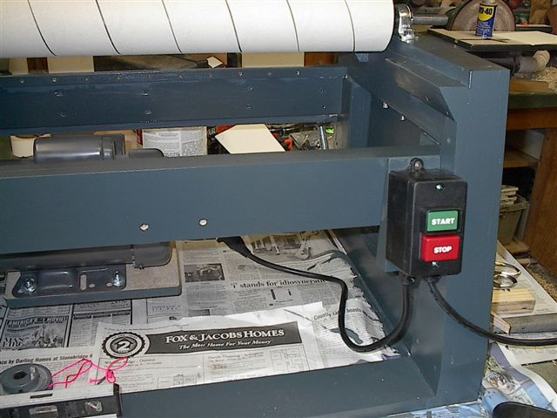
The on/off switch is from Rockler and is mounted to a wooden wedge so that the face of the switch is on the same angle as the front edges of the sander. This is the same switch that is used on my band saw and is very convenient and easy to use. I wanted the switch on the right side because of the proposed 16” disk sander that I plan on installing on the right hand end of the shaft. If you look closely, you can see the shaft protruding about 3” from the right hand side of the sander. The wire connecting the switch to the motor was attached to the rear frame cross member using a nylon locking tie.

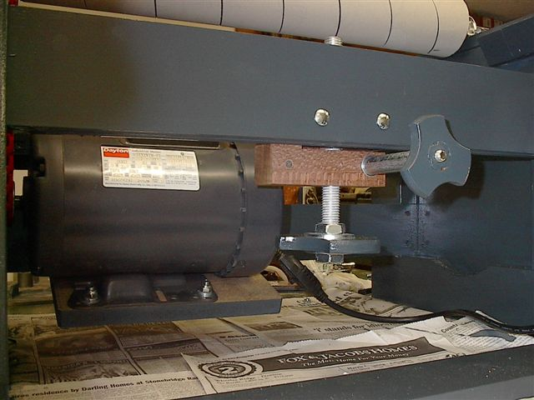
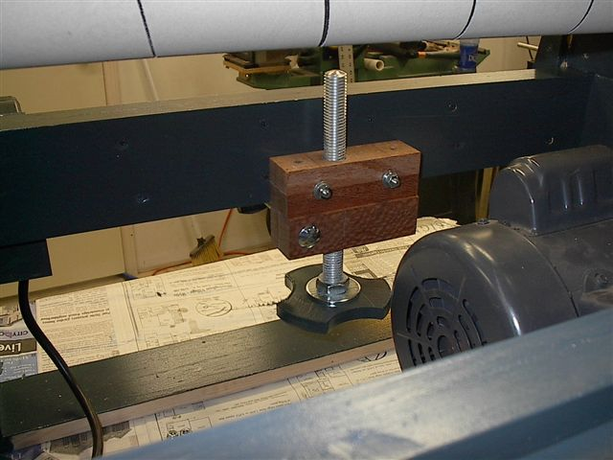

Two more views showing the elevation mechanism from the back and front. The rounded over end of the threaded elevation rod fits nicely into the hole (without protruding through) of the large nylon washer which provides the bearing surface on the underside of the table bed.

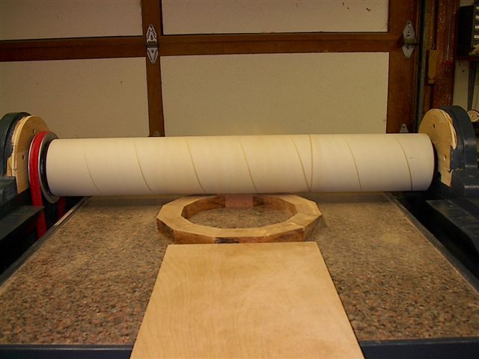
Here you can see the first “test run” to determine if the bed is parallel with the V-drum. Following the pdf plan, you would sand the plywood epoxied drum with sand paper attached to a flat surface. Enough sanding and the drum would be flat and parallel with the bed.
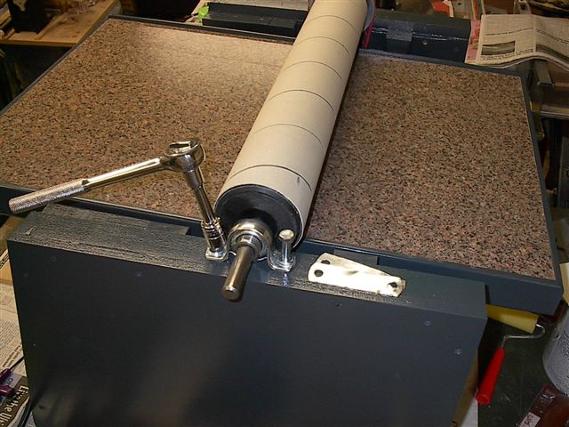
Since I started with a polycarbonate drum that had Velcro & sandpaper already attached, my only option to align the V-Drum and the bed of the sander was to “shim” the low bearing block until the surface was even with the table the entire width of the bed. Here you see me adding “shop made” sheet metal shims to raise this end of the V-Drum.

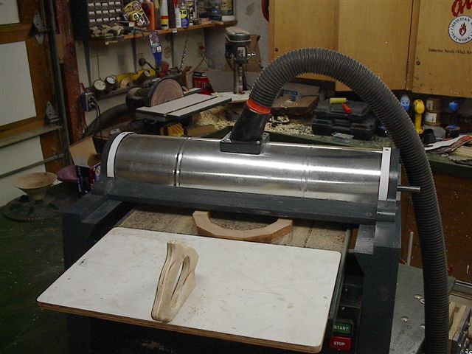
Another “test run, this time with my dust collector hose attached. The push guide tool is made from ½” MDO with
¾” plywood handle attached with screws. The push guide is slightly smaller than the width of the bed (20”) and is long enough to push the sanded piece past the V-Drum roller. This “baby” really puts out the dust and a dust collection system is a MUST! Many thanks to Dominic for his website and email encouragement. Also, I must extend great appreciation to the unknown but highly valued luthier who supplied the pdf plan to Dominic. This was a great project to build and even more fun to use.

Copyright © Raymond Lanham 2005

Delta 18-36 Drum Sander: $789.99

Performax Pro 22-44: $1999.00

Doing it myself: Priceless!

*If you decide to make this sander, please send me a photo of your finished project and email me: ray.lanham@coeur-de-larbre.com if you have any questions that I might be able to answer to help you along the way. Also, please visit my website: www.coeur-de-larbre.com
and take a look at the bowls I make with this tool.

