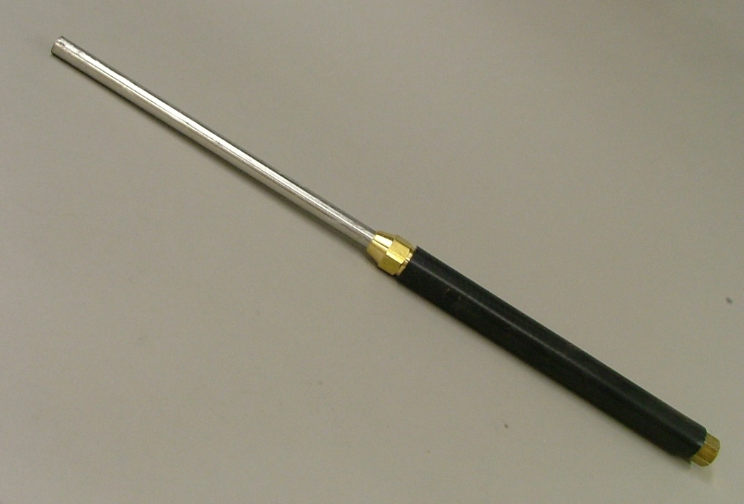
Shop-Made Carbide Tool and Handle
By: Raymond Lanham

Ever desiring to replicate new tool technology and seemingly always short of the extra cash to buy those expensive “designer named tools”, I came upon: http://mysite.verizon.net/respwkup/stuff/id11.html
featuring Paul Engle’s idea of using brass compression fittings with galvanized pipe and his article inspired this variation. Total Cost: $11.66 + carbide cutter of your choice.
You can make the handle to fit bowl gouges and other turning tools and easily remove the tool from the handle for sharpening. It’s the same concept as the OneWay Thread-lok Ferrule but you make the handle out of pipe rather than wood and fill it with shot or BB’s to dampen vibration. I used black pipe rather than galvanized pipe and no machining was required on the fittings. The handle may be made as long or as short as you want it to be. Materials consisted of:
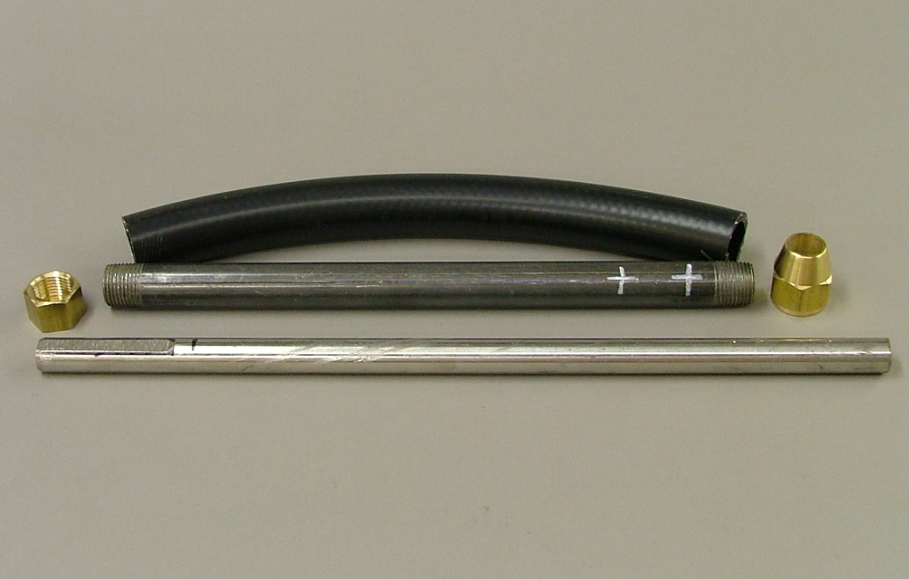
- ½”dia. x 12” long pipe nipple. $2.39

(1)12” of washing machine hose…$2.50

- ½” Brass Cap ……………......$1.79

- ½” Brass Flare nut .………….$1.79

- ¼” x ¼” socket set screws……$. 69

- 5/8 dia. Stainless Steel rod…....$2.50
Grinding a flat surface on the tool holder was necessary to allow the set screws a place to seat but also to avoid the small raised seam inside the pipe. The inside diameter of the ½” pipe handle is exactly 5/8” which allows a nice fit for the 5/8” stainless steel tool holder. Cold rolled steel will work just as well but I found the S.S. rod at my local scrap merchant for $2.50 and I always like a bargain.
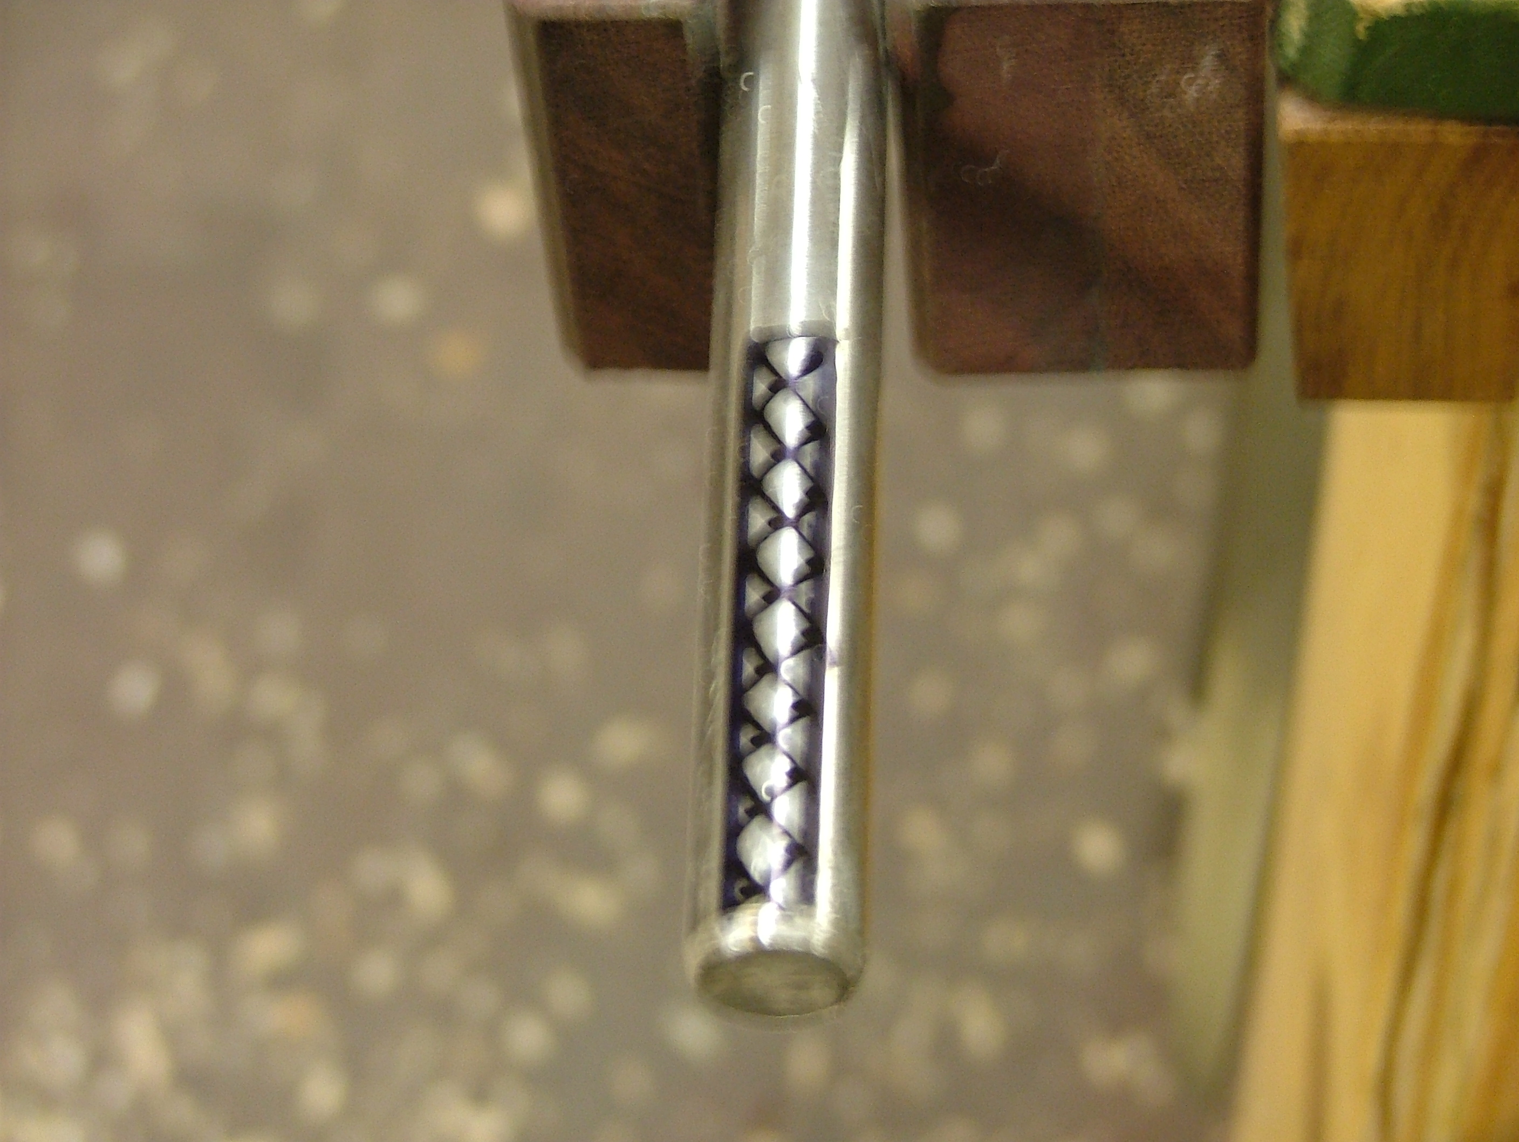
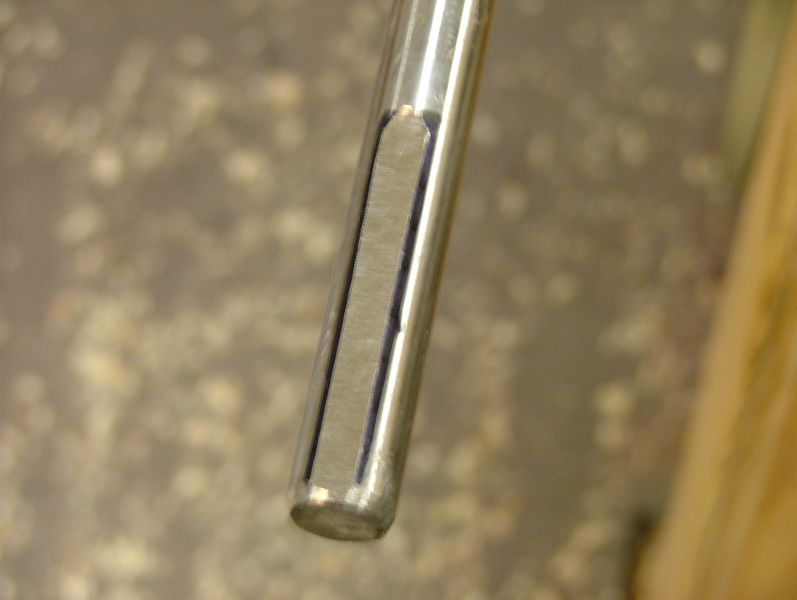

After marking the position of the set screw holes on the pipe, I transferred those marks to the washing machine hose and used a ¼” dia. hole punch and a wooden dowel inside the hose to punch the holes in the correct positions for the set screws. I then proceeded to drill the holes with a 13/64” bit and then tap the pipe with a ¼ -20 TPI for the ¼ x ¼ set screws. I also used stainless steel for the set screws.
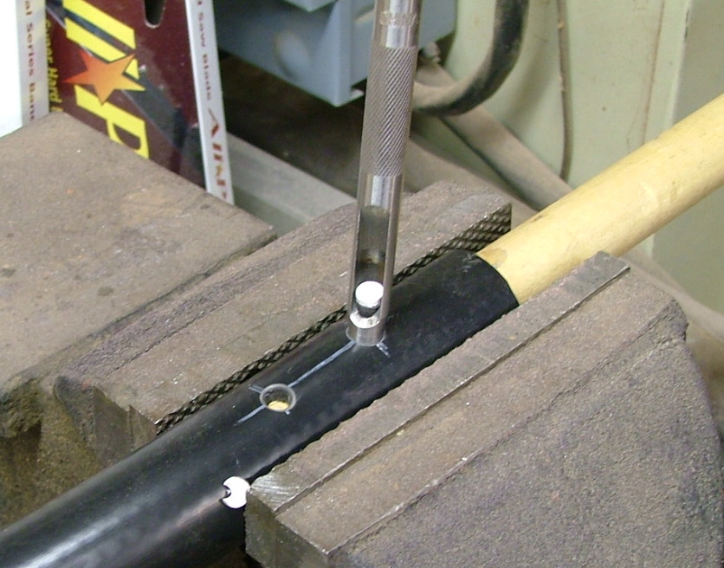
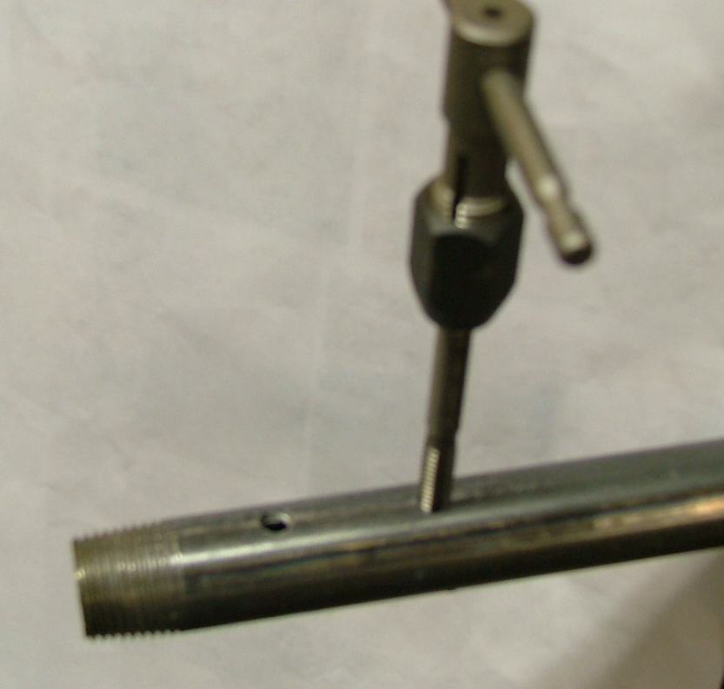

With the brass end cap tightened down, I proceeded to push the washing machine hose onto the pipe, taking care to align the set screw holes. The hose inside diameter is the same as the outside diameter of the pipe and will slide on with just a “smidge” of muscle motivation. With the set screws in place and the brass fittings screwed on, I inserted the S.S. rod and tightened the set screws. All that remains is to configure the end of the rod for the carbide cutter and I’m “home & hosed”.
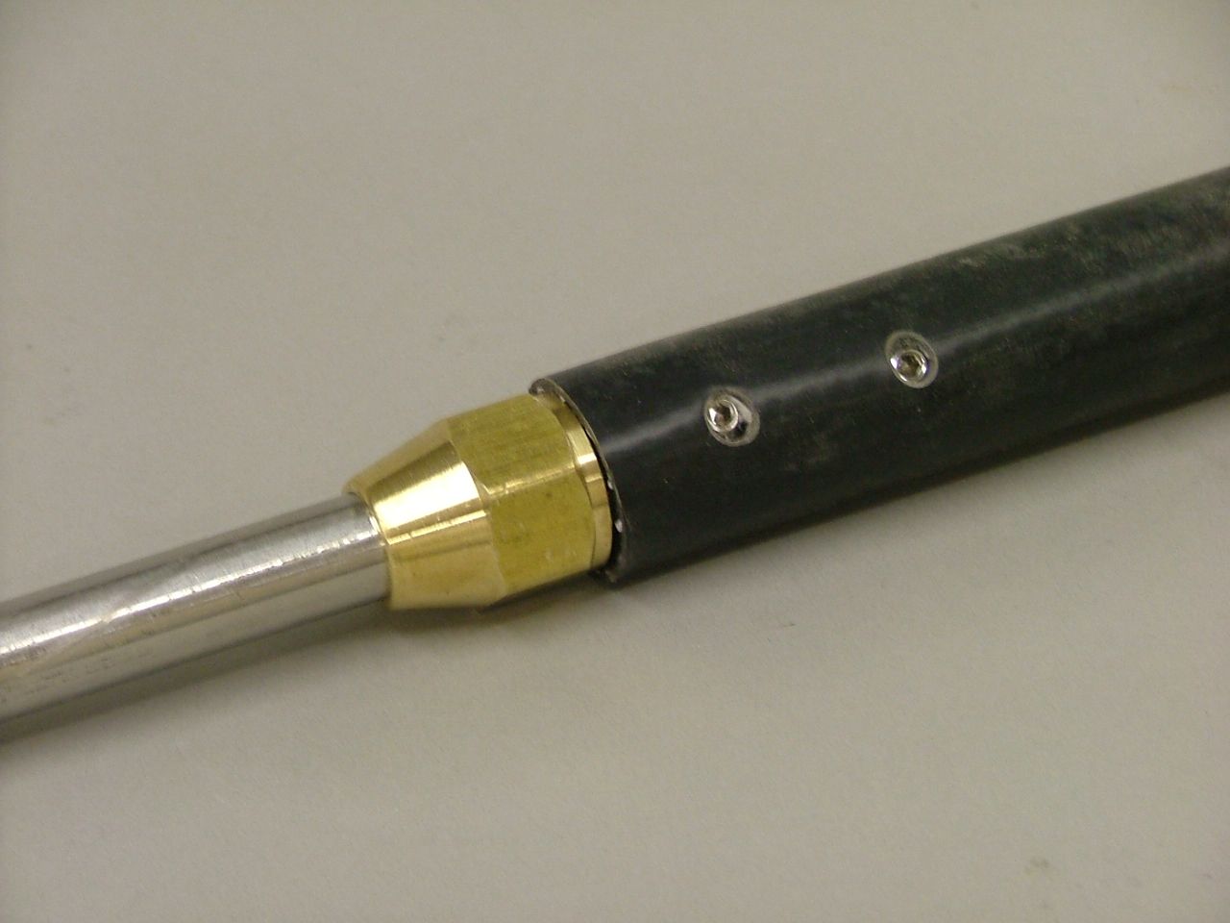

“Designer Name” Tool Handle……..$50.00

5/8 dia. bar w/carbide cutter……….$50.00

Doing it myself……………….PRICELESS!

